CS A407 Evolutionary Computing
Exam 2
Tuesday, March 26, 2013

This exam is open book, open notes, and open computers. Apart from writing down your answers, no form of communication is allowed.

Part I: Evolution Strategies

1. Consider the following population of μ = 3 individuals:

(5.0, -5.5, 1.0, 2.5, 0.8, -0.1, -0.5, 0.5)
(3.7, -2.3, 1.3, 2.4, 0.9, 0.1, -0.4, 0.4)
(-4.4, -4.7, 1.6, 2.3, 0.7, -0.3, -0.6, 0.3)

Here, n = 4 and we are using uncorrelated mutation with n step sizes. Assuming that discrete global recombination is used for the object variables and intermediary global recombination is used for the strategy parameters, show a child that might be created from this set of parents via recombination, and briefly explain how each value was computed.

2. Consider the following individual:
(2, 4, 6, 8, 0.2)
Here, n = 4 and we are using uncorrelated mutation with a single step size. Assume that τ = 1 / (n^{0.5}) and that a random number generator returns the following values from N(0, 1):
0.1, -0.9, -0.2, 0.9, 0.2
(a) Determine the learning rate τ for this problem.
(b) Use the first random number to determine the value of the new strategy parameter, σ‘.
(c) Use the next four random numbers and the updated strategy parameter to calculate the new value of x₁, x₂, x₃, and x₄.

3. Consider an ES that uses μ = 3, λ = 21. Parents A, B, and C have fitness 15, 23, and 17, respectively. The children and their fitnesses are:

d = 24 e = 37 f = 26 g = 18 h = 32 i = 19 j = 27
k = 222 l = 79 m = 33 n = 28 o = 51 p = 127 q = 231
r = 28 s = 16 t = 31 u = 41 v = 44 w = 34 x = 100

Also assume that LOWER FITNESS IS BETTER.
(a) Use comma selection (μ, λ) to determine the survivors.
(b) Repeat the previous part using plus selection (μ + λ)

Part II: Evolutionary Programming

4. Draw a finite state machine that could be evolved by using traditional EP to predict the sequence (0 1 0 1 1 0 0 0 1)⁺ perfectly.

Part III: Genetic Programming

5. Show the parse tree corresponding to the following arithmetic expression:

4 (xy + 6) – (yz + 12x) + 17

6. Consider the following parse trees:
First crossover point
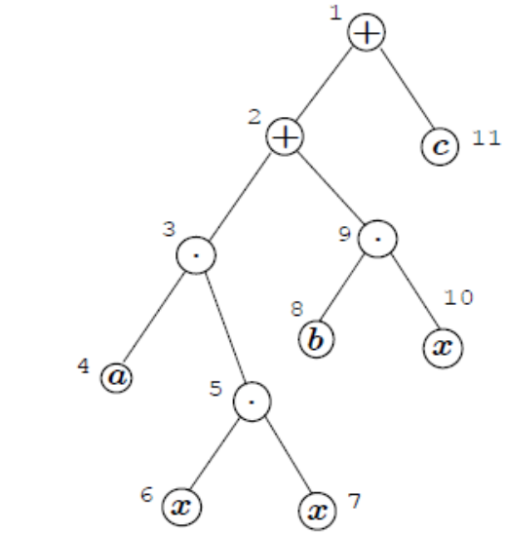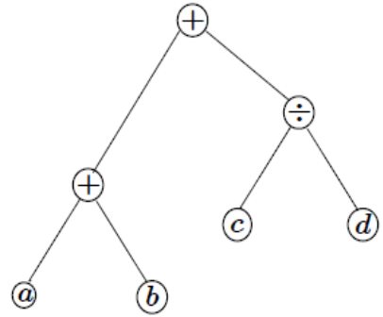
Second crossover point

(a) Assume that these trees have been selected as parents to participate in sub-tree crossover, and that the selected crossover points are indicated by the arrows. Draw the resulting two children.

(b) Assume that the parent shown on the left has been selected for mutation, and the mutation occurs for the subtree rooted at point 3 (the left-most multiplication operator). Draw a child that might be created as a result.

